Pinball machines have all kinds of targets.
The pinball machine in assignment 4 will only have 4 different types of targets.
The following shows what these 4 target types look like.

Bumpers

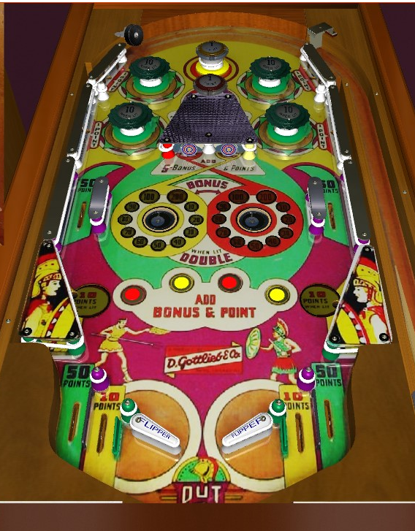 | Kickers  Rollovers  Flippers

